TITLE

Author

Position, School Name

Contact Number

**I. Content and Rationale**

1. Define the IV and DV and connect them with studies
2. Provide a brief discussion of the intervention and studies related to intervention
3. Connect the proposed intervention on the Learning Outcome or Independent Variable and other variables (**with reviewed RRL at least 10 local and 5 foreign**)
4. Context or results of assessment or earning outcome/output in the schools/district/division
5. Connect to the general problem or the research title. Providing the GAPS

**II. Action Research Questions**

State the General Objectives

State the Specific research Questions

**III. Proposed innovation, Intervention, and Strategy**

Dependent Variable

Intervention/Proposed Solution

Output

**IV. Action research Methods**

**Research Design**

Describe the research design to be used – define and qualify the design based on the research questions and the data requirements. See example on the slides provided

State that the study is an action research type.

1. **Participants and/or Other Sources of Data and Information**

Who or what will be the sample for your study?

Why and how did you select these samples/respondents/participants?

How many? Provide the details through a tabular presentation – may provide profiles of the respondents with discussion.

Who will validate the interventions or instructional materials? How many? what are their qualifications?

1. **Data Gathering Methods**

1. What tool will you use in gathering the data? Should match the research design to be sued.

2. Discuss if you will use survey, interview, open-ended questions, observations, document review/analysis and explain the process how will you undergo such data gathering.

3. For questionnaire/survey type who will make the questionnaire and validate the tools?

**Table 1: Schedule of Data Gathering Activities**

| **Data Gathering Activities** | **Date and Time** | **Person Involve** |
| --- | --- | --- |
| 1. Development of the tool (Research Questionnaire, IMs, LAS etc) |  |  |
| 2. Request to conduct data gathering to respondents |  |  |
| 3. Validation of Research Tools |  |  |
| 4. Revision of the Instruments |  |  |
| 5. Pilot testing (if applicable) |  |  |
| 6. Revision of Instruments ready for the intervention |  |  |
| 7. Conduct of the pre-test |  |  |
| 8. Implementation of the Intervention |  |  |
| 9. Conduct of the post-test |  |  |
| 10. Interview with the select respondents (if applicable) |  |  |

* 1. *paragraphs may do)*

1. ***Plan for Data Analysis***

(These are examples only)

1. To determine the set of learning materials to be developed based form the results of the conducted quarter 1 assessments, the mean percent scores will be computed and will be describes as:

|  |  |  |
| --- | --- | --- |
| **Mean Percent Score (MPS) per competency** | **Level** | **Qualitative Description for the Learning Competency** |
| 90-100% | Advanced | Mastered |
| 80 – 89.99% | Meets Expectation |
| 70 – 79.99% | Partial Mastery | Average Mastery |
| 60 – 69.99% | Low Mastery | Least Mastered |
| 0 – 59.99% | No Mastery |

3. To describe the mastery level of the Grade VI leaners along the concepts of percent, ratio and proportion and basic operations, a standard-based rating will be used and its descriptions are given below.

Table 3: Mastery Level Descriptions

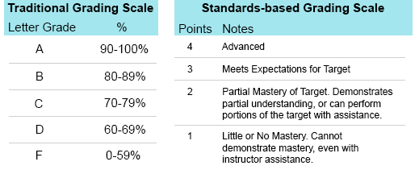

Standard-based rating (2019).

Mean and Standard Deviation will be computed to describe the overall level of mastery of the students. Frequency and Percent Distribution will also be presented to show the summary of the level of mastery of the students in Mathematics.

OR

To describe the performance level of the Grade VI leaners along the concepts of percent, ratio and proportion and basic operations, a standard-based rating will be used and its descriptions were given using the table below.

Table 2: Mathematics Performance Descriptors

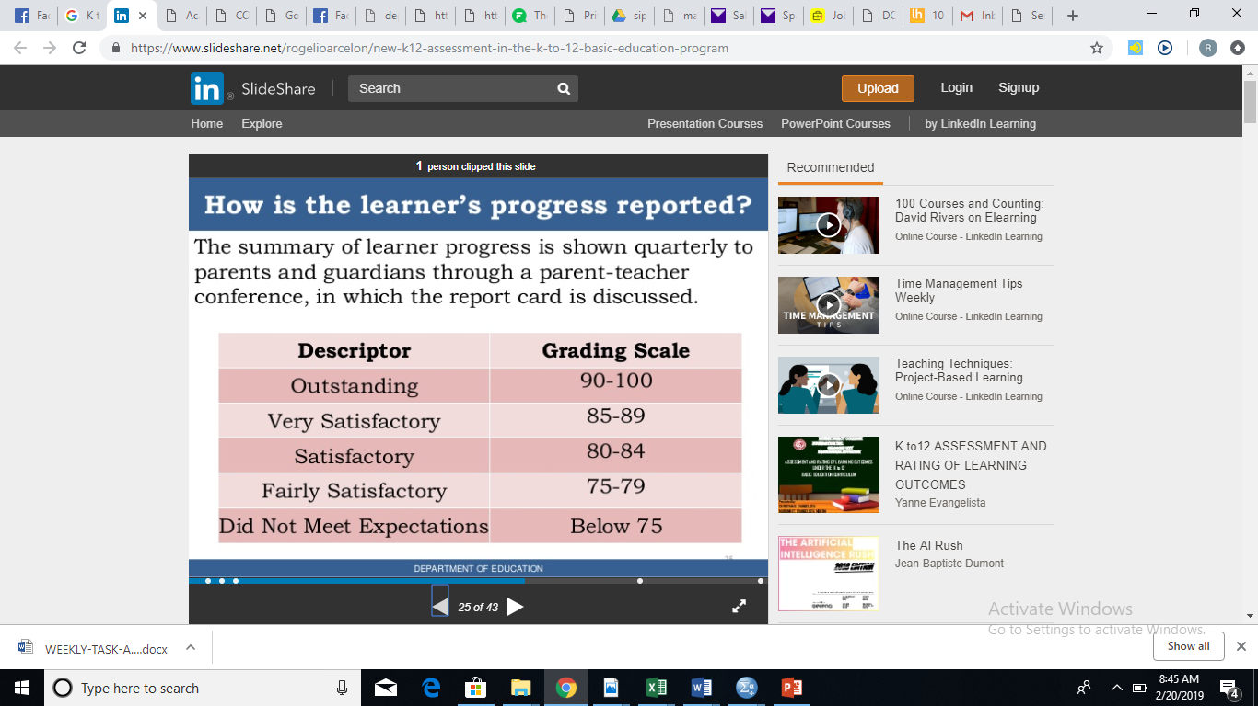

DepEd Order No. 8, s. 2015. Policy Guidelines on Classroom Assessment for K to 12 Basic Education Program

Mean and Standard Deviation will be computed to describe the overall level of performance of the students. Frequency and Percent Distribution will also be presented to show the summary of the level of performance of the students in Mathematics.

OR

To determine the levels of achievement among Grade 8 Learners on Elementary Statistics during the first quarter, scores on their pretest will be converted to mean percent scores (MPS) and will be interpreted based on the table.

Table 1. Achievement Level Descriptions

|  |  |  |
| --- | --- | --- |
| **Mean Percent Scores (MPS)** | **Level** | **Qualitative Description** |
| 90 – 100 | Advanced | Superior performance. Have deep understanding of the topic reflected by having consistent high scores in the assessments. |
| 75 – 89.99 | Proficient | Solid academic performance. Have understanding of the lessons/subject-matter and can work independently or with little supervision of the teacher |
| Below 75 | Basic | Partial understanding of lessons/subject-matter, needs teacher’s supervision for the lesson |

*(for questions 4)*

To determine significant difference on the mastery level of learners before and after the conduct of the (intervention), paired t-test will be used and will be set at 5% level of significance. Change scores will be computed from their pre and post test scores, change/difference of the scores will be tested significantly using one-sample t-test with t>30% as the t-test value of comparison.

*(for questions 5)*

To describe the recommendations and suggestions of the evaluators for the improvement of the developed instructional materials on ____________, these will be thematically analyzed through open and axial coding systems. *Open coding*, known as first level of coding, looks into distinct concepts and categories in the data (basic unit of analysis) and breaks down data into first level concepts and second-level categories. While, *Axial coding* uses concepts and categories to confirm concepts and categories accurately represent the gathered responses and to explain how concepts and categories are related (Creswell, 2007).

1. **Research ethics**

**Discuss use of consent form/waiver for learners, observation of data privacy act, anti-plagiarism and absence of conflict of interest. Discuss anonymity of participants if involved in interview etc.**

**V. Action Research Workplan and Timeliness**

**(pwedeng landscape)**

| Research Activities | (specify the months) | | | |  | | | |  | | | |
| --- | --- | --- | --- | --- | --- | --- | --- | --- | --- | --- | --- | --- |
| 1st Week | 2nd Week | 3rd Week | 4th Week | 1st Week | 2nd Week | 3rd Week | 4th Week | 1st Week | 2nd Week | 3rd Week | 4th Week |
| 1. Development of the tool (Research Questionnaire, IMs, LAS etc) |  |  |  |  |  |  |  |  |  |  |  |  |
| 2. Request to conduct data gathering to respondents |  |  |  |  |  |  |  |  |  |  |  |  |
| 3. Validation of Research Tools |  |  |  |  |  |  |  |  |  |  |  |  |
| 4. Revision of the Instruments |  |  |  |  |  |  |  |  |  |  |  |  |
| 5. Pilot testing (if applicable) |  |  |  |  |  |  |  |  |  |  |  |  |
| 6. Revision of Instruments ready for the intervention |  |  |  |  |  |  |  |  |  |  |  |  |
| 7. Conduct of the pre-test |  |  |  |  |  |  |  |  |  |  |  |  |
| 8. Implementation of the Intervention |  |  |  |  |  |  |  |  |  |  |  |  |
| 9. Conduct of the post-test |  |  |  |  |  |  |  |  |  |  |  |  |
| 10. Interview with the select respondents (if applicable) |  |  |  |  |  |  |  |  |  |  |  |  |
| 11. Conduct of data analysis |  |  |  |  |  |  |  |  |  |  |  |  |
| 12. Finalization of research manuscript |  |  |  |  |  |  |  |  |  |  |  |  |
| 13. Approval of Research |  |  |  |  |  |  |  |  |  |  |  |  |
| 14. Binding of Research |  |  |  |  |  |  |  |  |  |  |  |  |

**VI. Cost Estimates**

(specify the financial needs in the activity – include source of fund)

|  |  |  |  |
| --- | --- | --- | --- |
| **Activity** | **Item Description/**  **Particular/Needs** | **Cost** | **Total Amount** |
| 1. Development of the tool (Research Questionnaire, IMs, LAS etc) |  |  |  |
| 2. Request to conduct data gathering to respondents |  |  |  |
| 3. Validation of Research Tools |  |  |  |
| 4. Revision of the Instruments |  |  |  |
| 5. Pilot testing (if applicable) |  |  |  |
| 6. Revision of Instruments ready for the intervention |  |  |  |
| 7. Conduct of the pre-test |  |  |  |
| 8. Implementation of the Intervention |  |  |  |
| 9. Conduct of the post-test |  |  |  |
| 10. Interview with the select respondents (if applicable) |  |  |  |
| 11. Conduct of data analysis |  |  |  |
| 12. Finalization of research manuscript |  |  |  |
| 13. Approval of Research |  |  |  |
| 14. Binding of Research |  |  |  |
| Total | | |  |
| Source of Fund | | |  |

**VII. Plans for Dissemination and Utilization**

Results of the study will be beneficial to the improvement of learning outcomes in the school particularly on the subject _________, hence this will be disseminated through various activities such as:

|  |  |  |  |
| --- | --- | --- | --- |
| **Strategies** | **Activities for utilization and Dissemination** | **Timeframe** | **Resources Needed** |
|  |  |  |  |
|  |  |  |  |
|  |  |  |  |
|  |  |  |  |
|  |  |  |  |

**VIII. References**

(Use either 7th Edition of the APA Style of referencing).